**Django Ecommerce Project Report**

**Project Overview**

The django-ecommerce-project is an ongoing web application designed for an

ecommerce platform. The project has recently seen several key updates and additions,

which are outlined below.

Admin Signin Page

An Admin Signin Page has been implemented, providing a secure and authenticated

login interface for administrators.

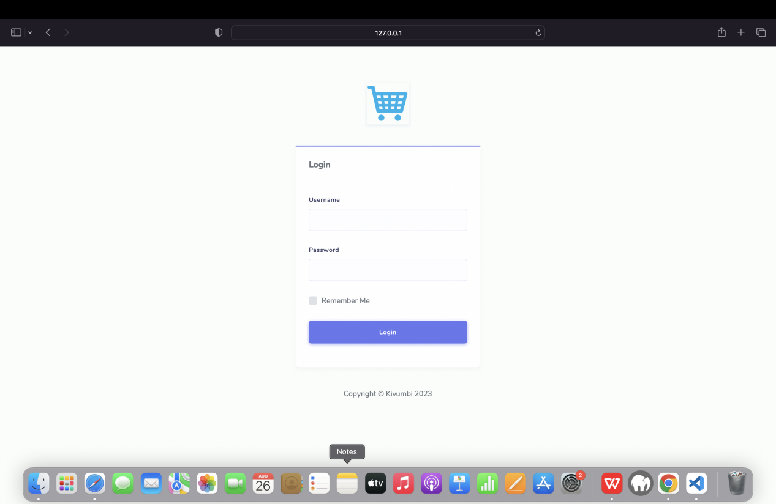

Admin Signin Page

Admin Category Management

Category Create Page

The Category Create Page allows administrators to create new product categories,

enriching the variety of items available for customers.

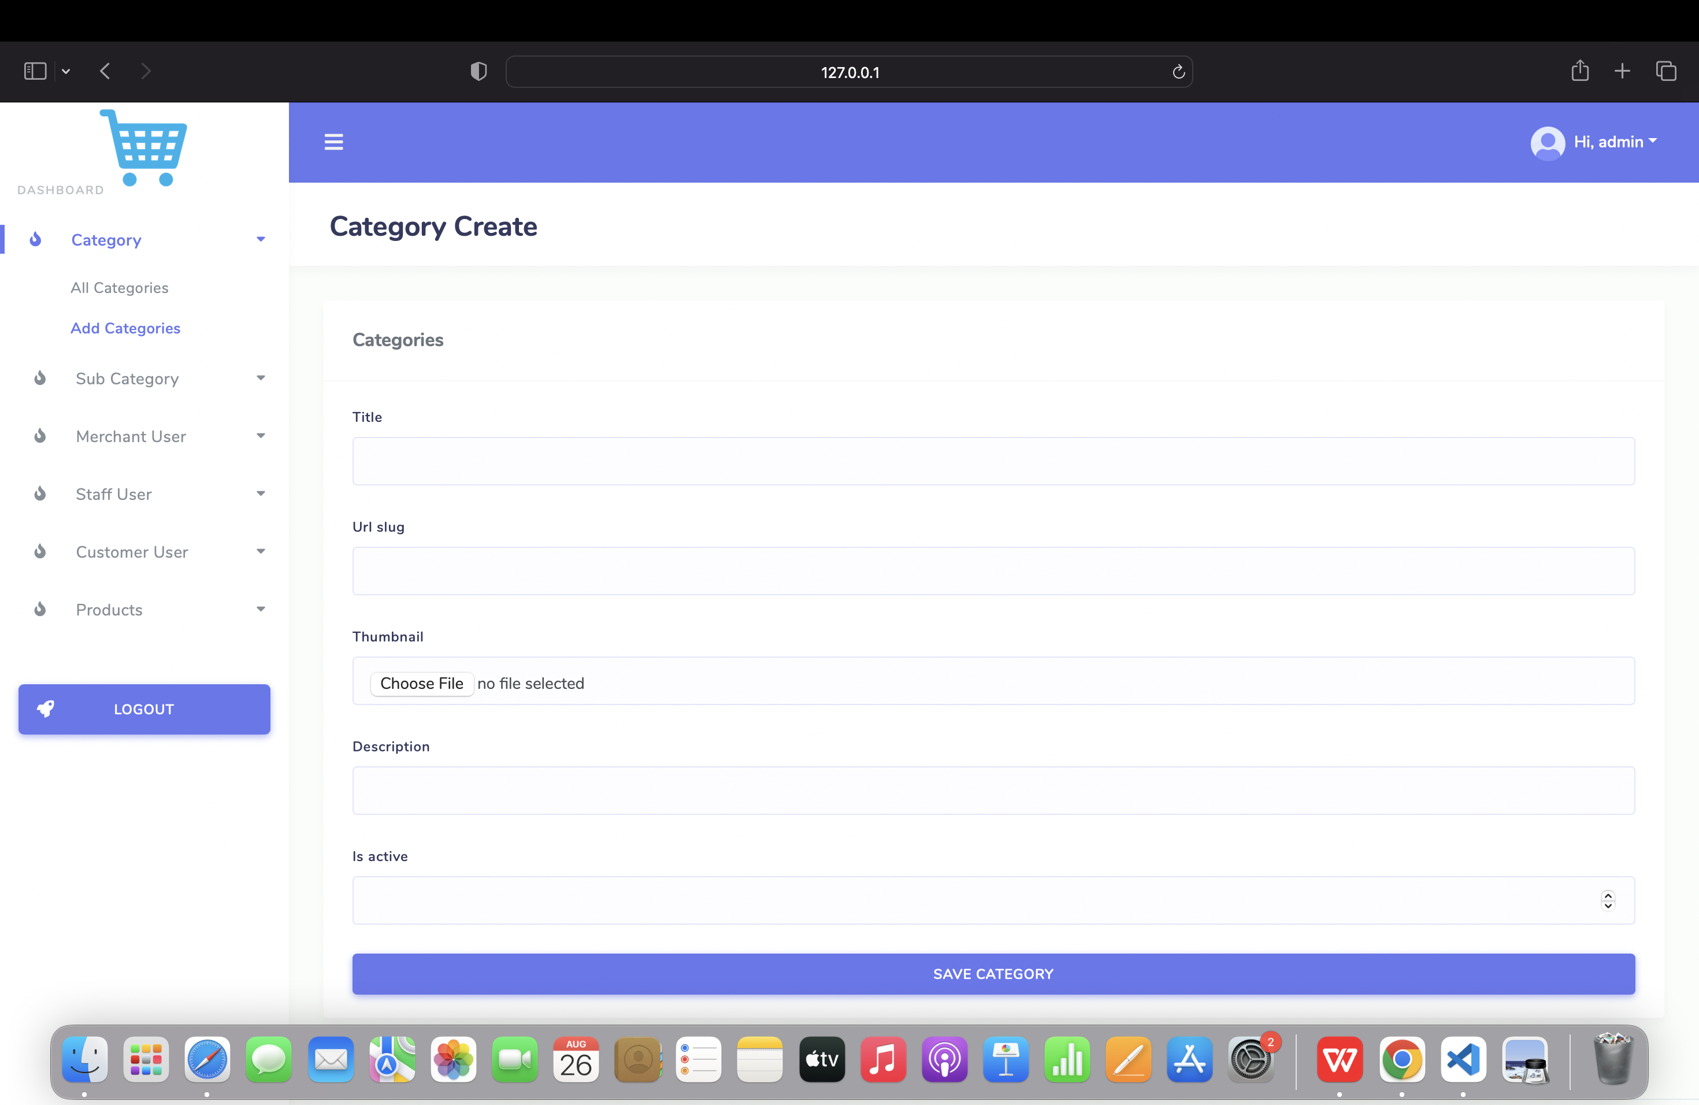

Category Create Page

Category List Page

The Category List Page displays a comprehensive list of all available product

categories within the ecommerce platform.

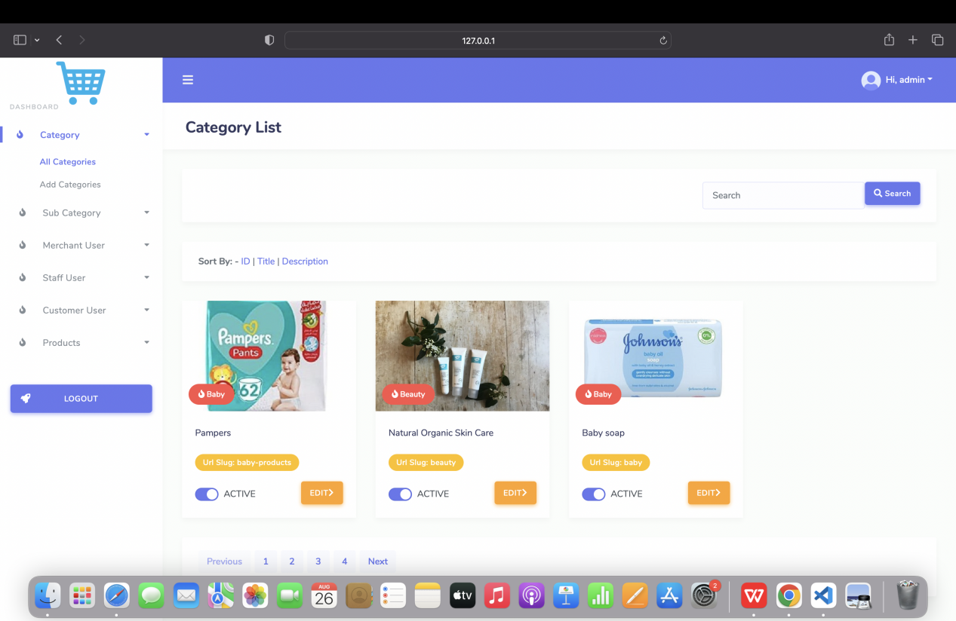

Category List Page

Category Update Page

Administrators can utilize the Category Update Page to modify and update existing

product categories, ensuring accurate and up-to-date information.

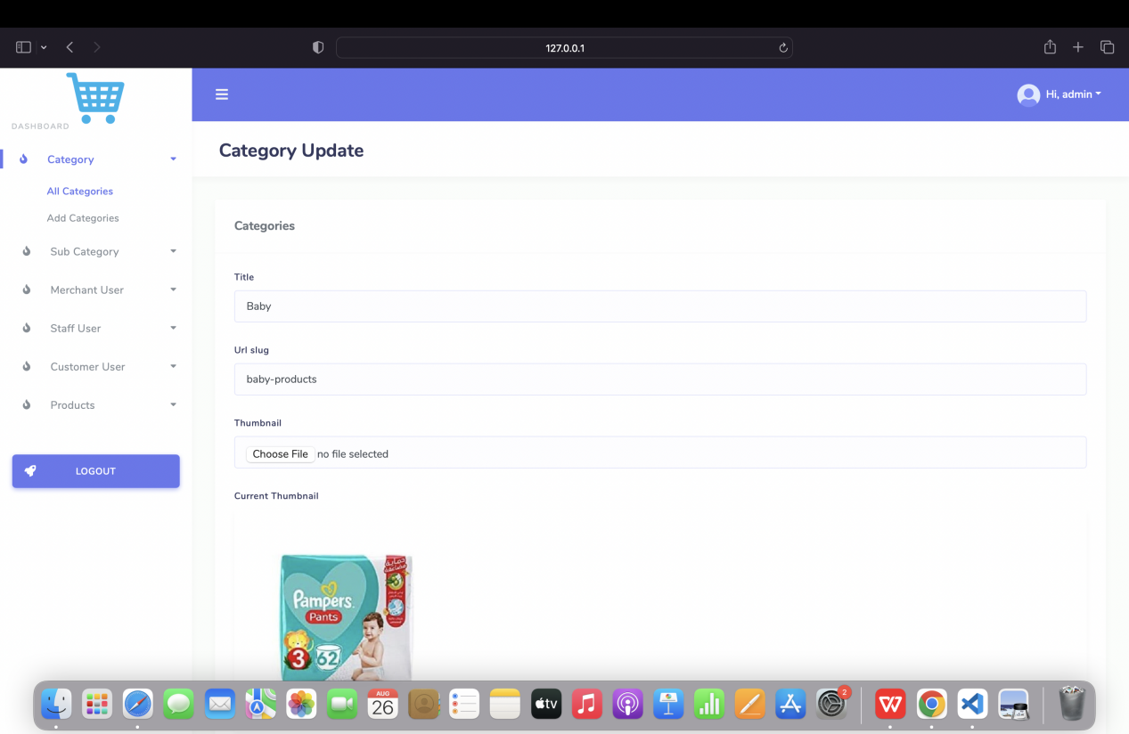

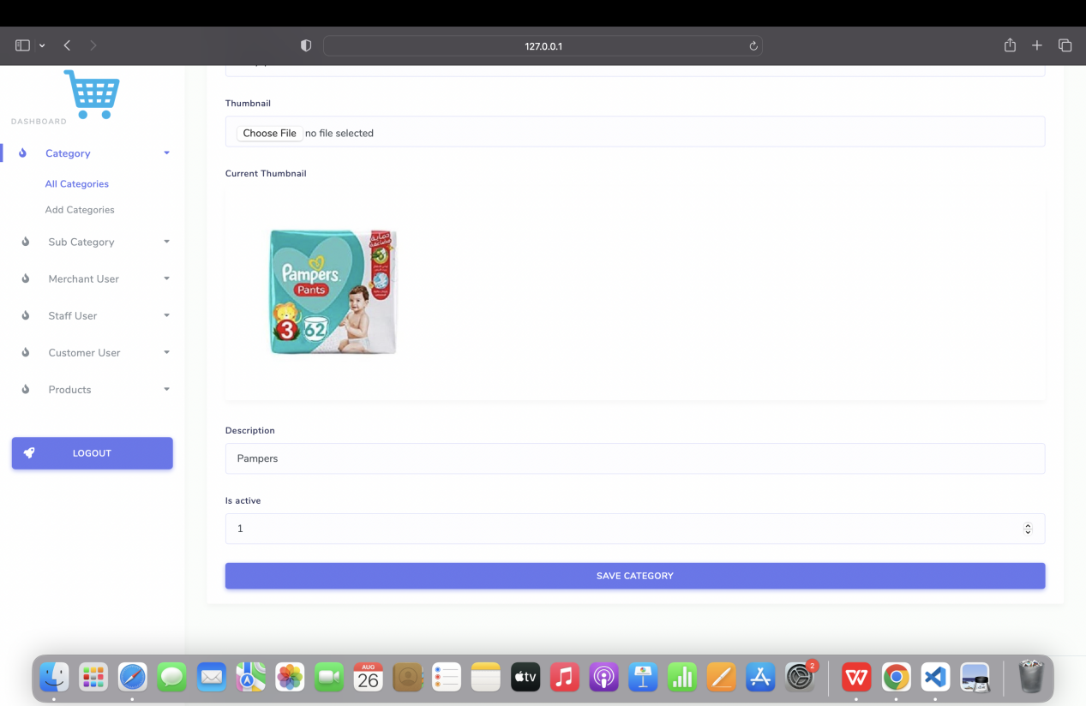

Category Update Page

Admin Sub Category Management

Sub Category Create Page

Administrators can now create new sub-categories using the Sub Category Create

Page, enhancing the organization of product listings.

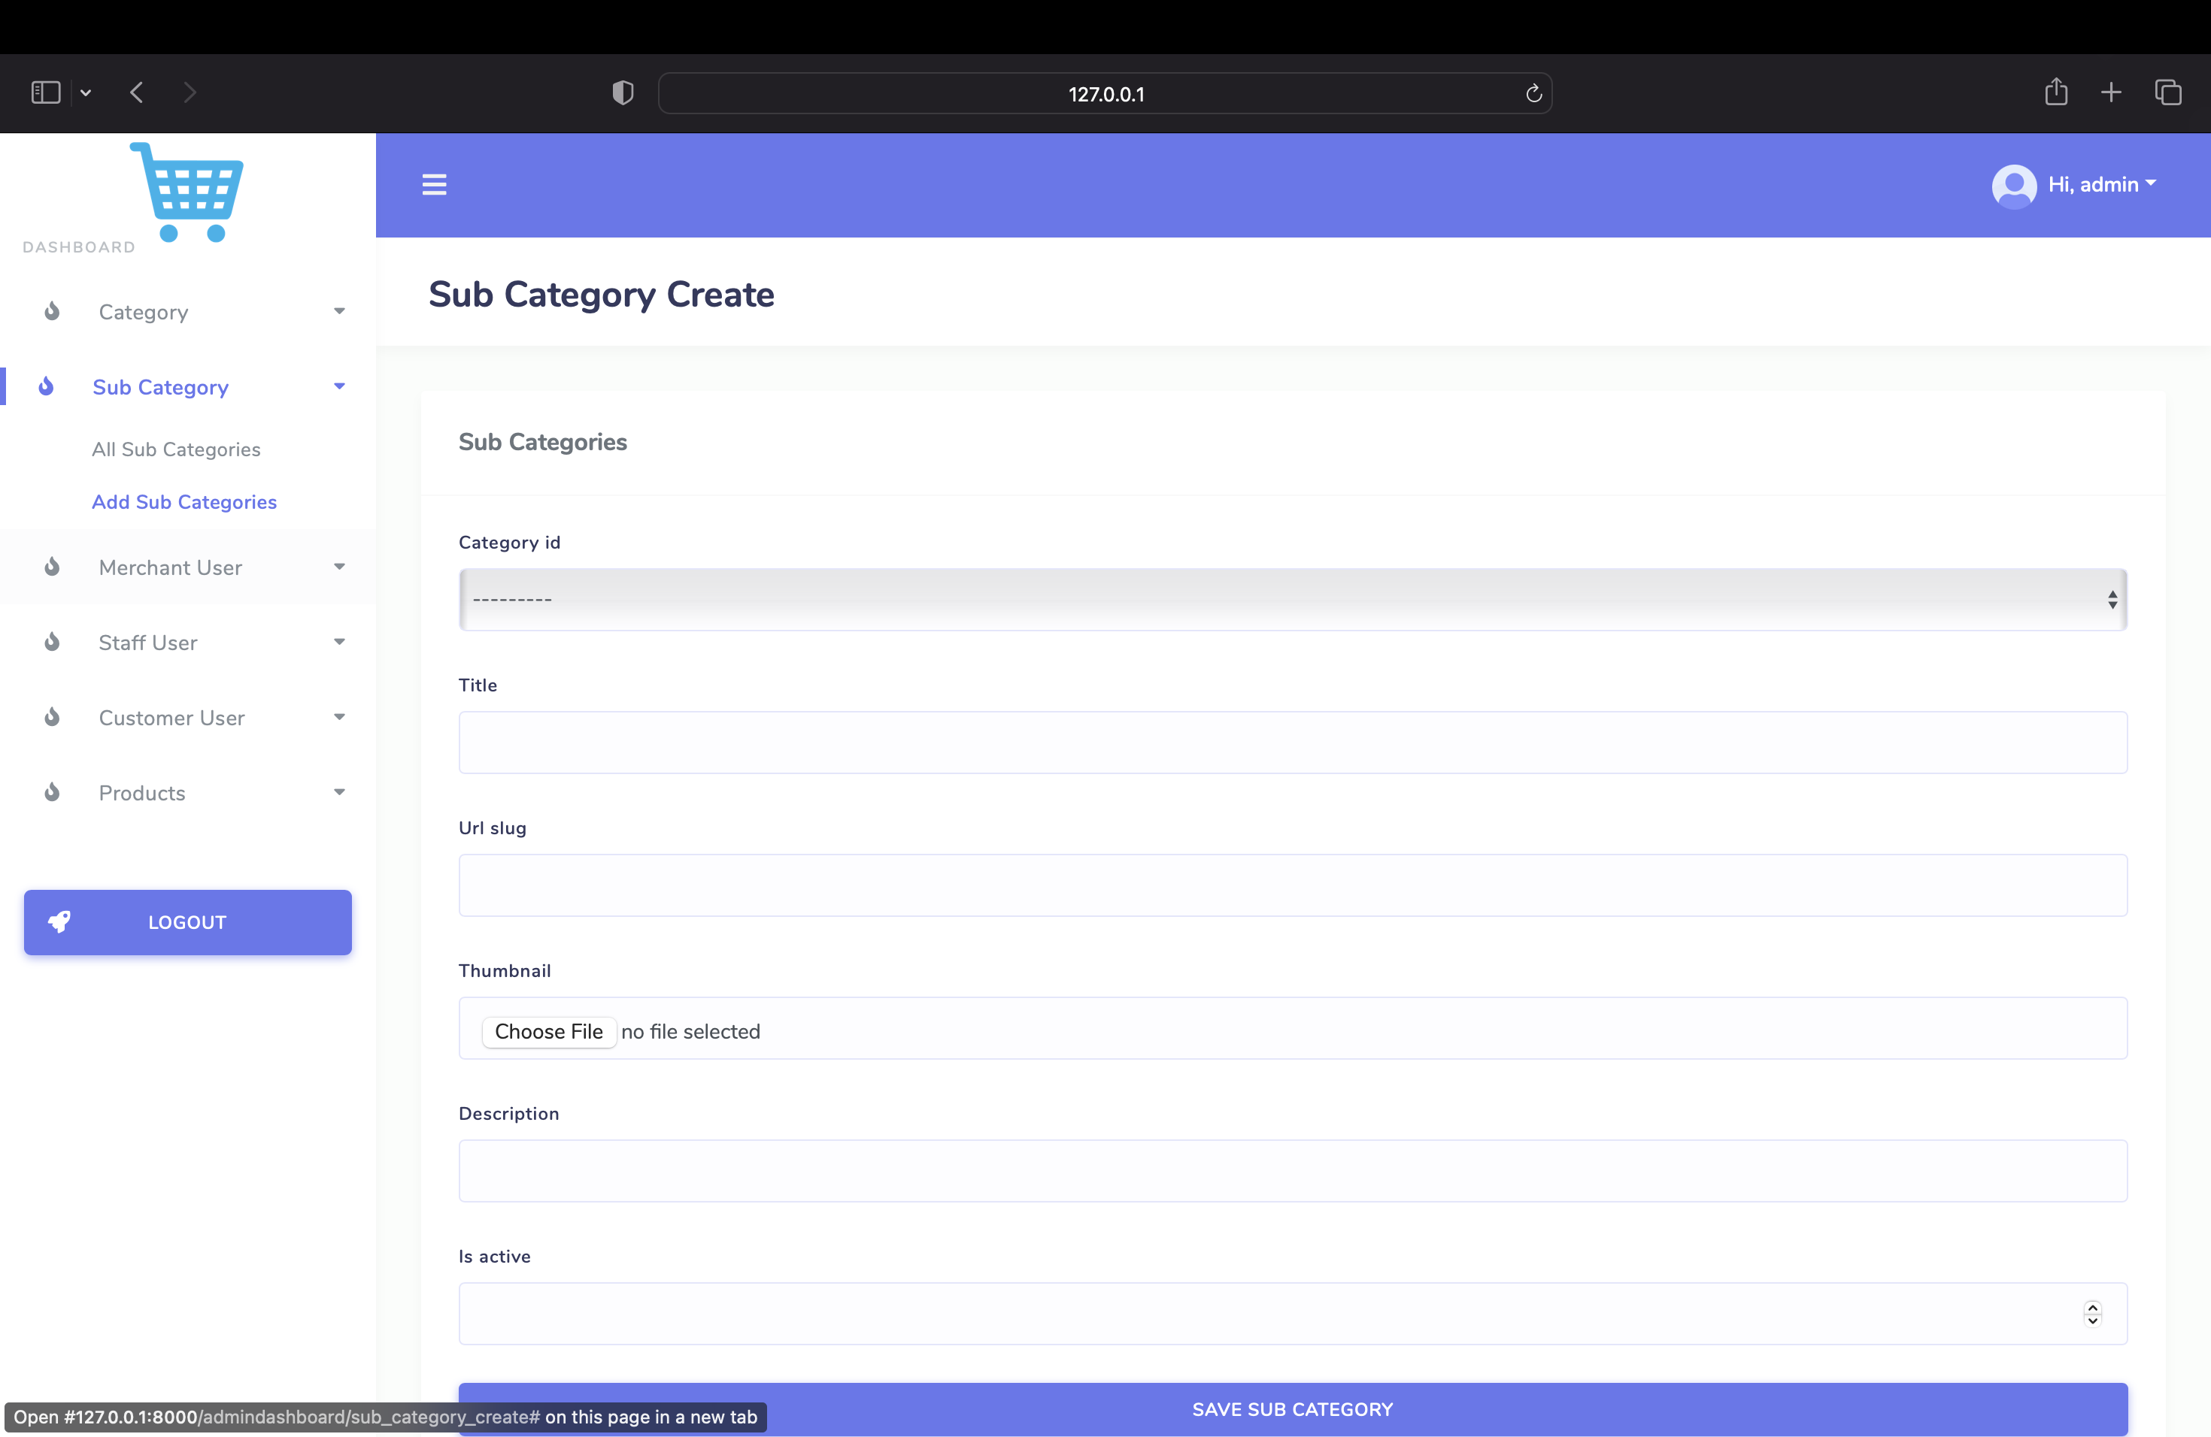

Sub Category Create Page

Sub Category List Page

The Sub Category List Page has been introduced to manage the sub-categories

associated with the main product categories.

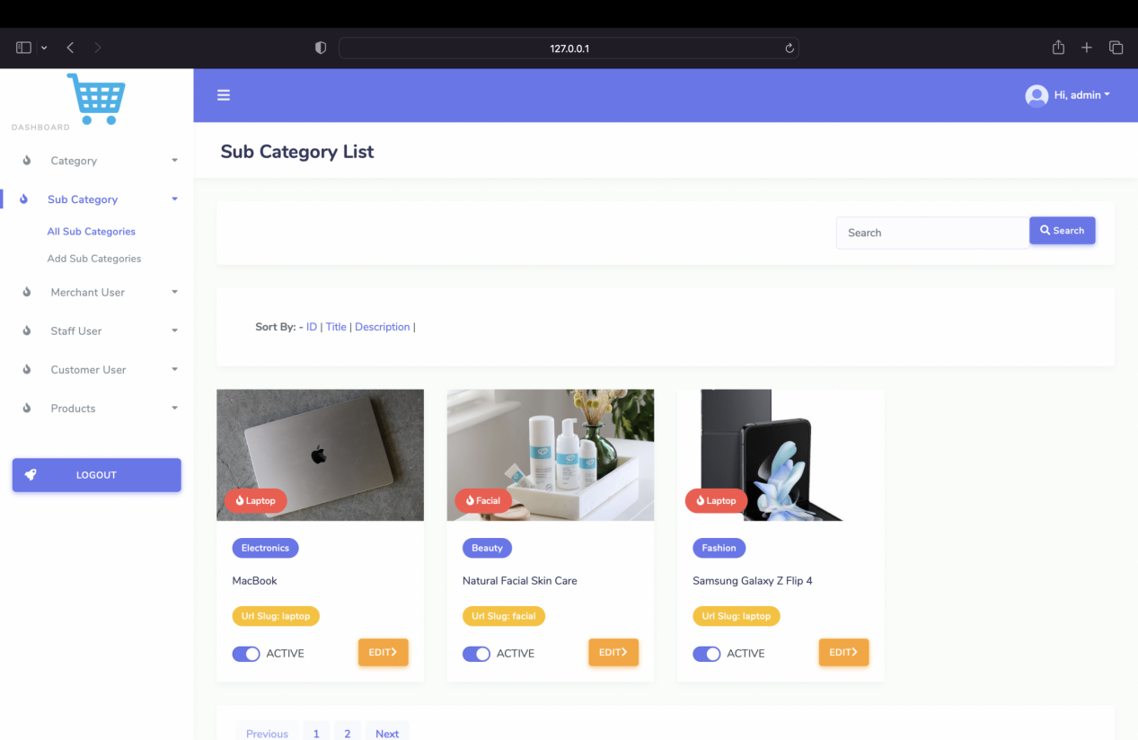

Sub Category List Page

Sub Category Update Page

Similar to main categories, the Sub Category Update Page enables administrators to

make changes to existing sub-categories.

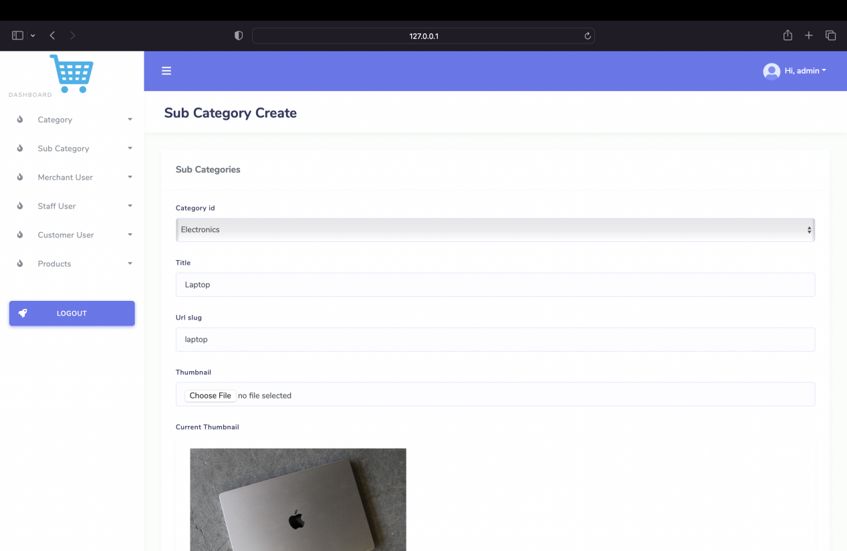

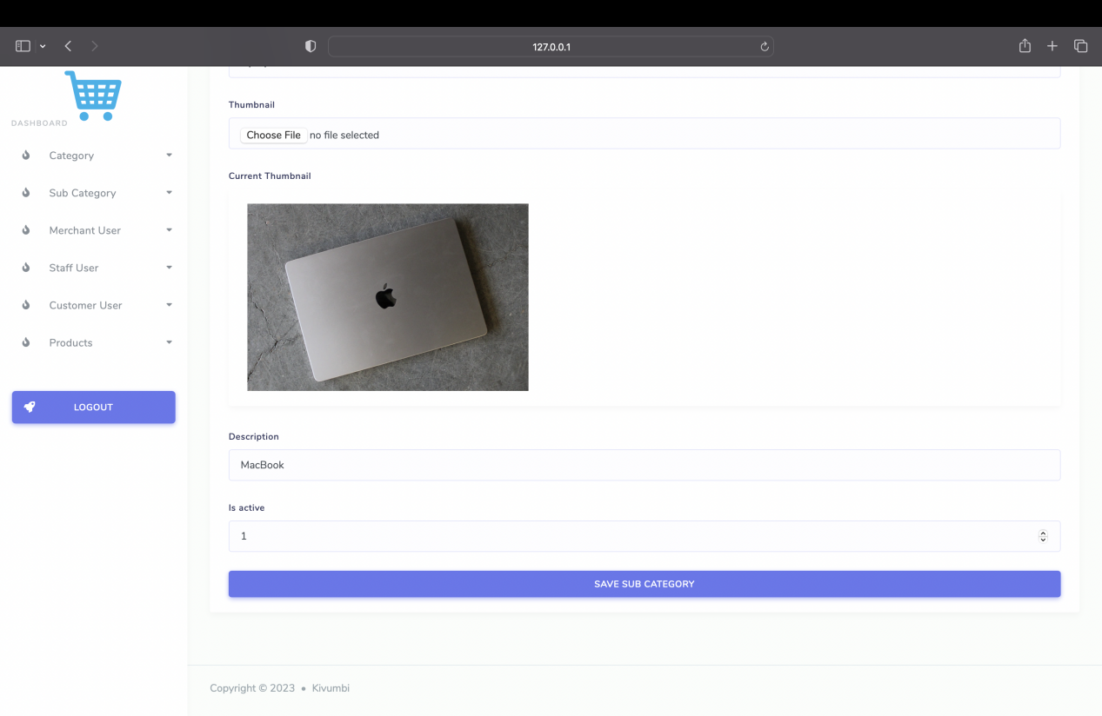

Sub Category Update Page

Admin Merchant Management

Merchant Create Page

The Merchant Create Page facilitates the addition of new merchants to the ecommerce

platform, expanding the available product offerings.

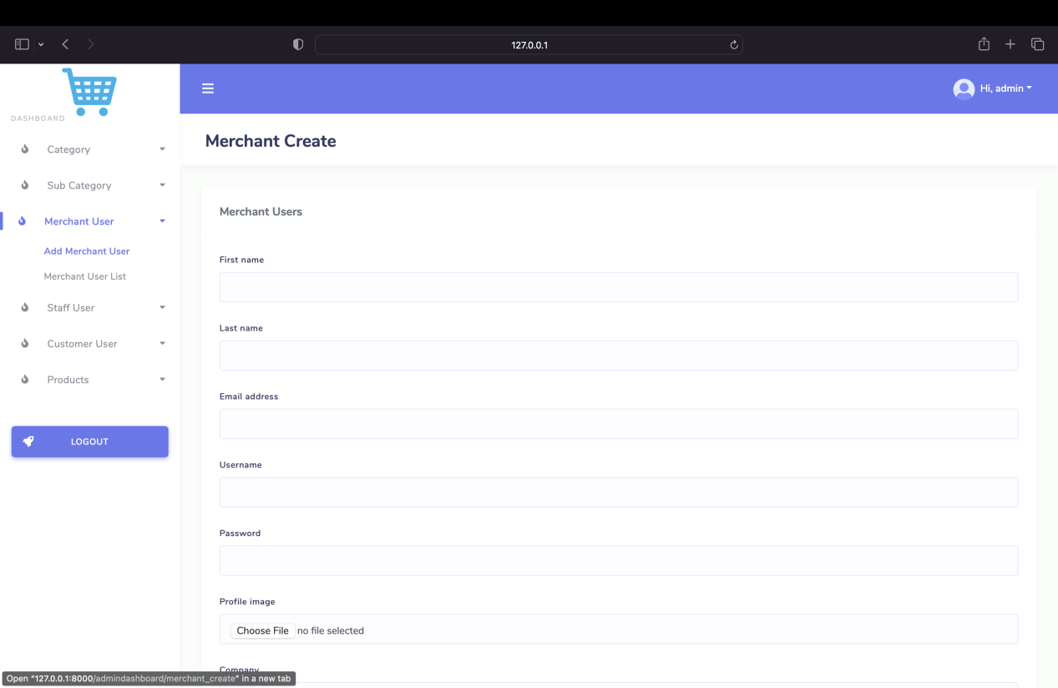

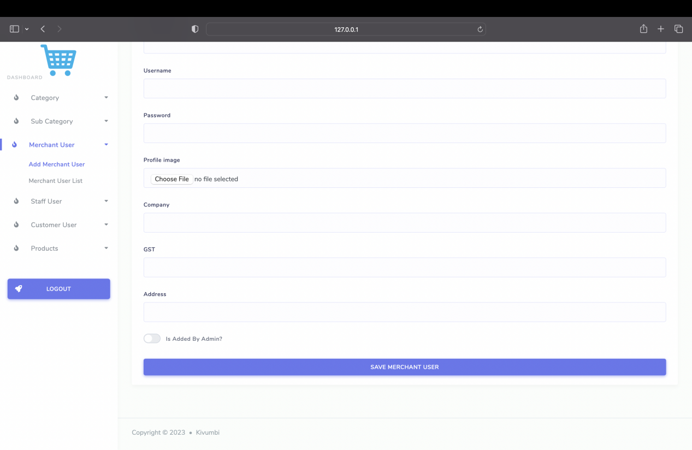

Merchant Create Page

Merchant List Page

The Merchant List Page provides an overview of all registered merchants,

streamlining administrative tasks related to merchant management.

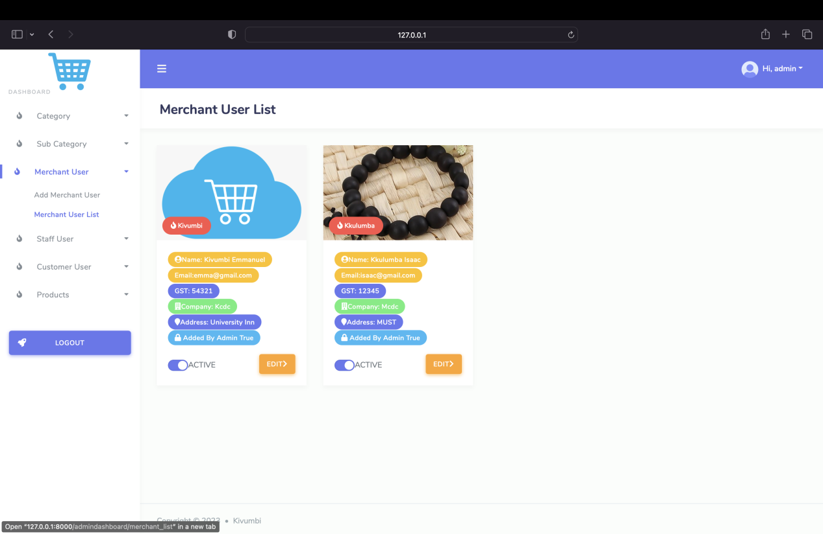

Merchant List Page

Merchant Update Page

Administrators have the ability to update merchant details and information through

the Merchant Update Page.

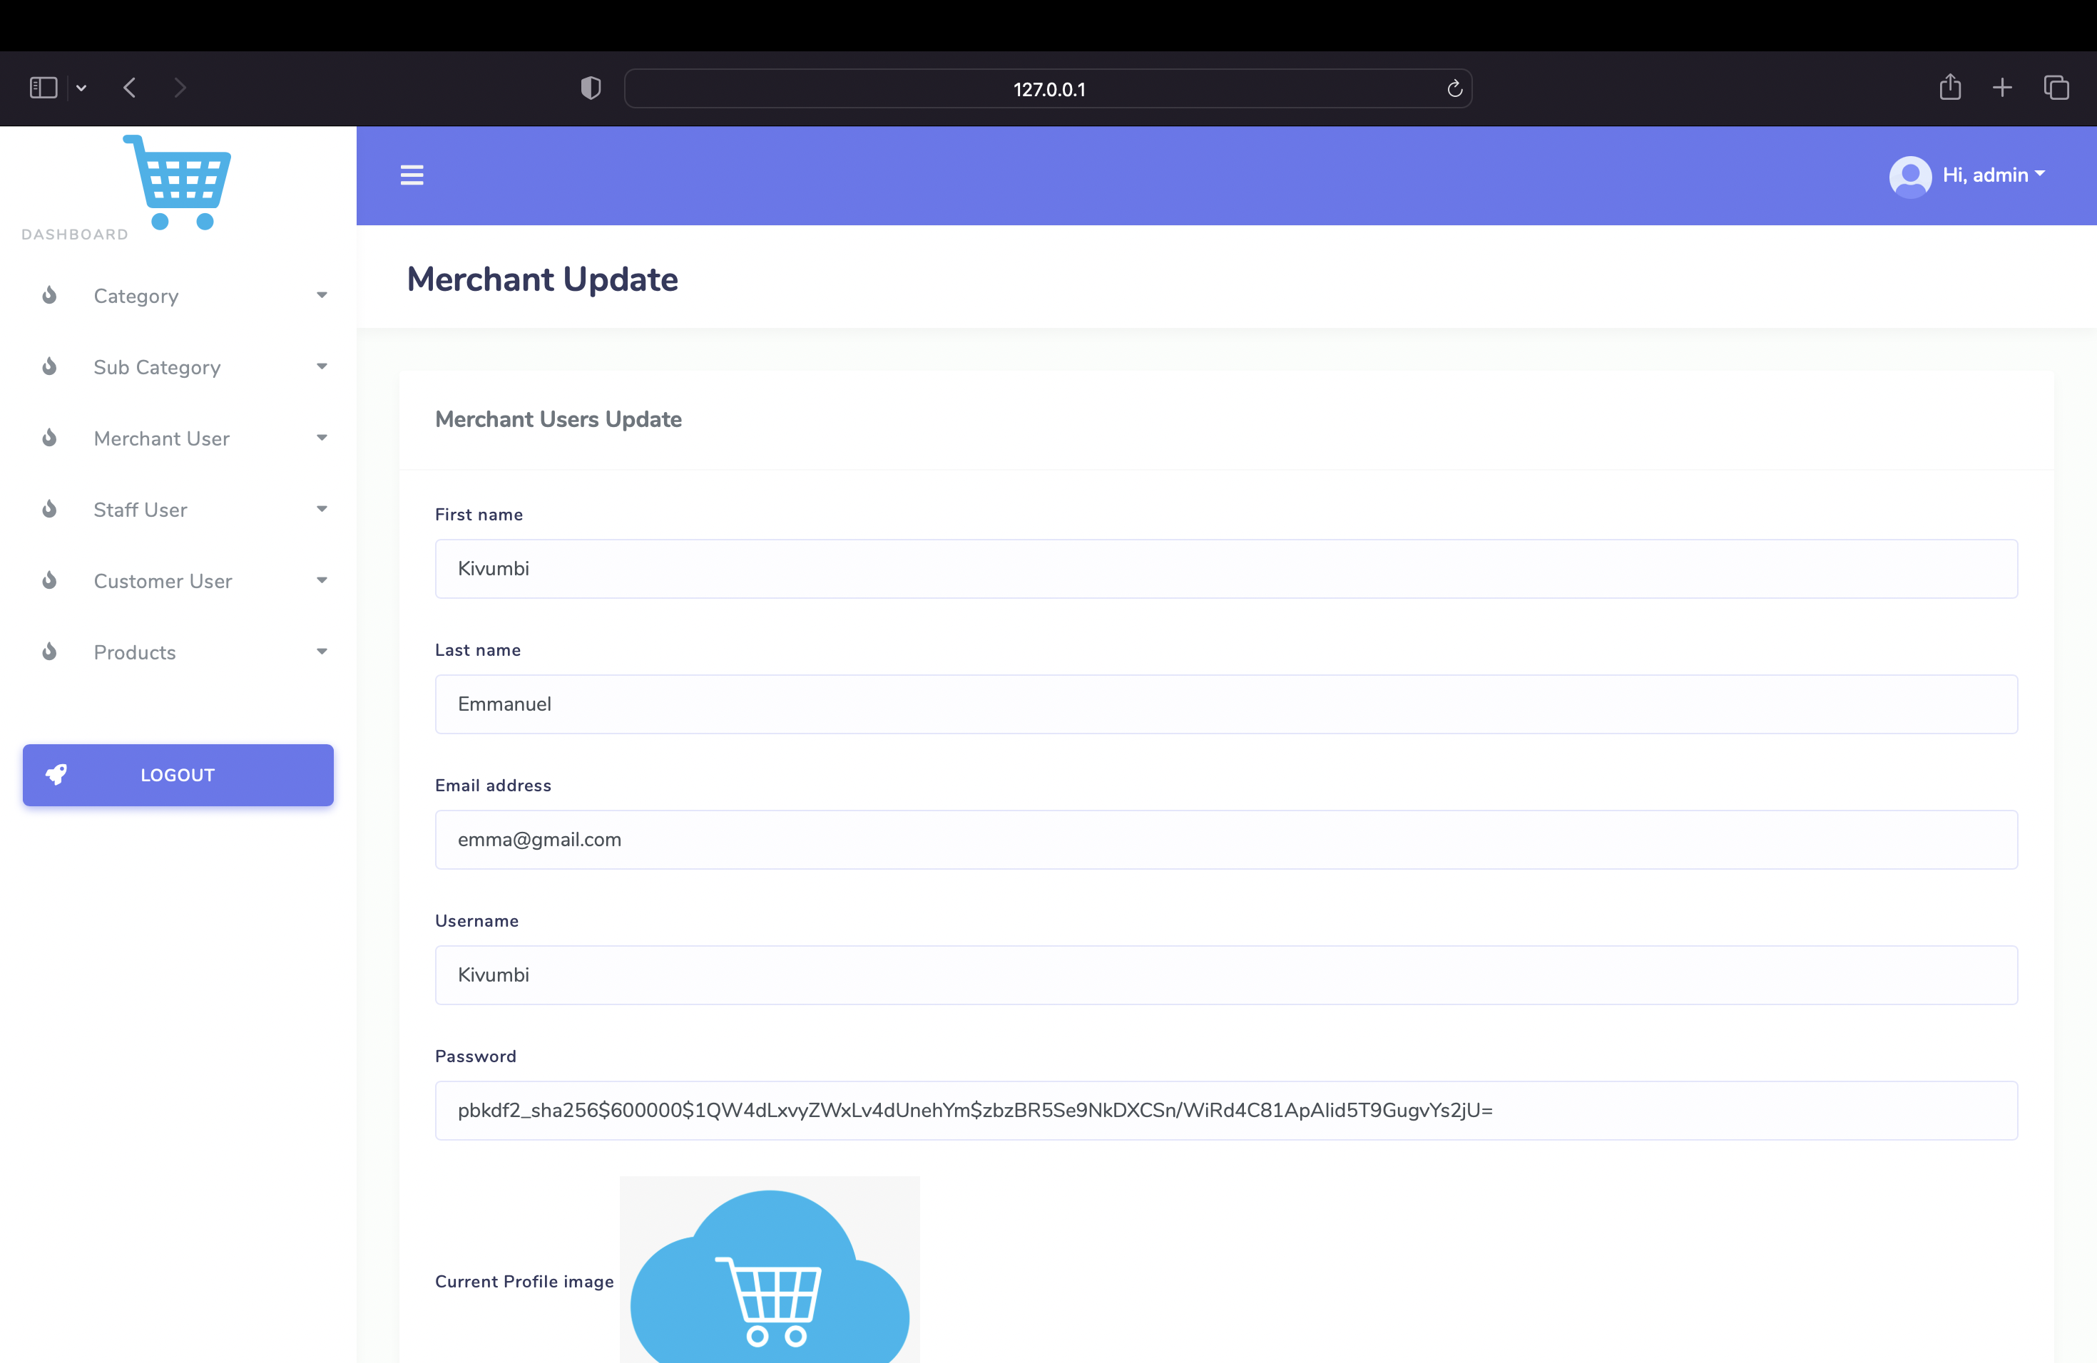

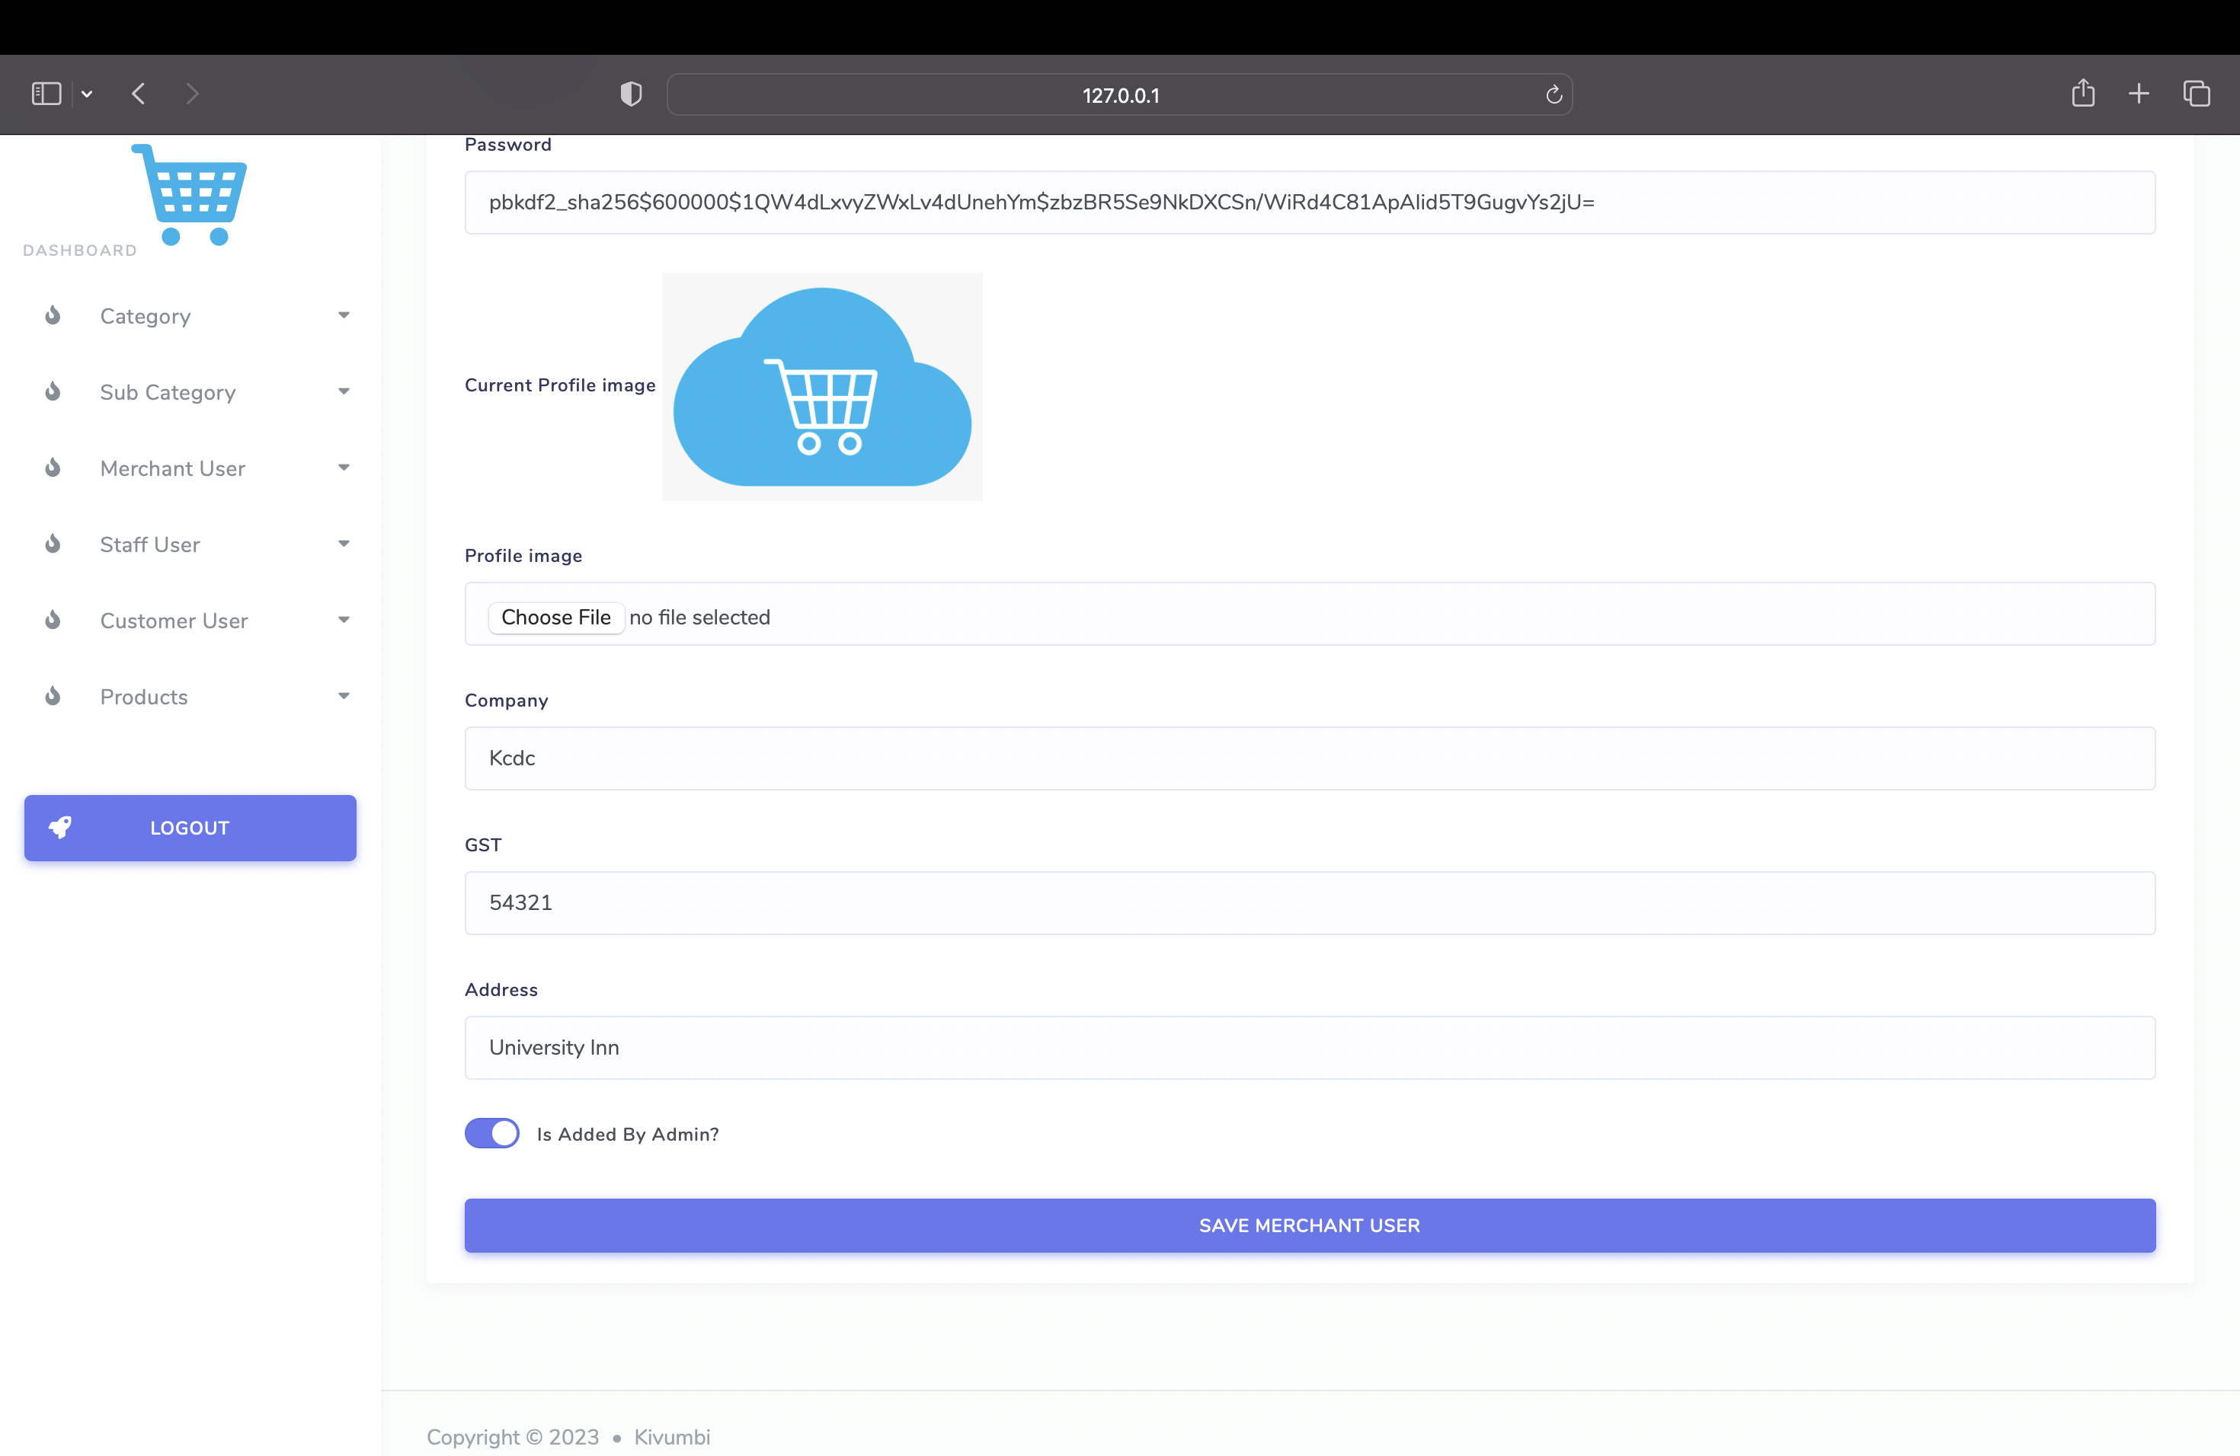

Merchant Update Page

Enhanced Features

Several features have been introduced to improve user experience and site

functionality:

Searching, Sorting, and Pagination

The Searching, Sorting, and Pagination features enhance the user's ability to

efficiently navigate and explore the product categories.

Searching,

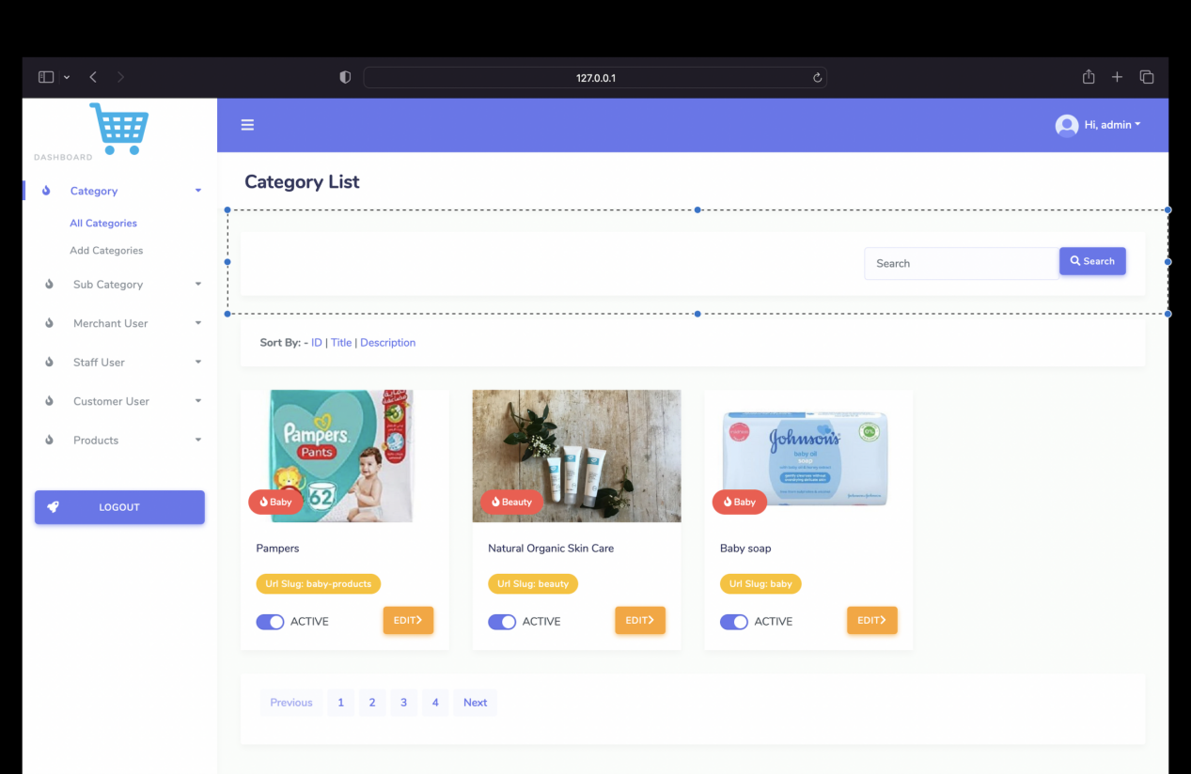

Sorting,

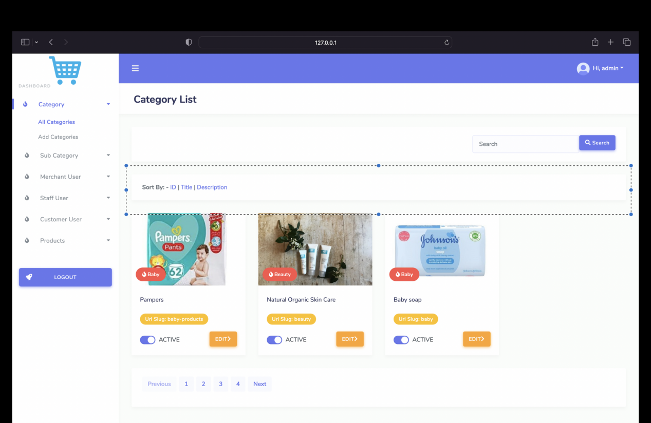

and Pagination

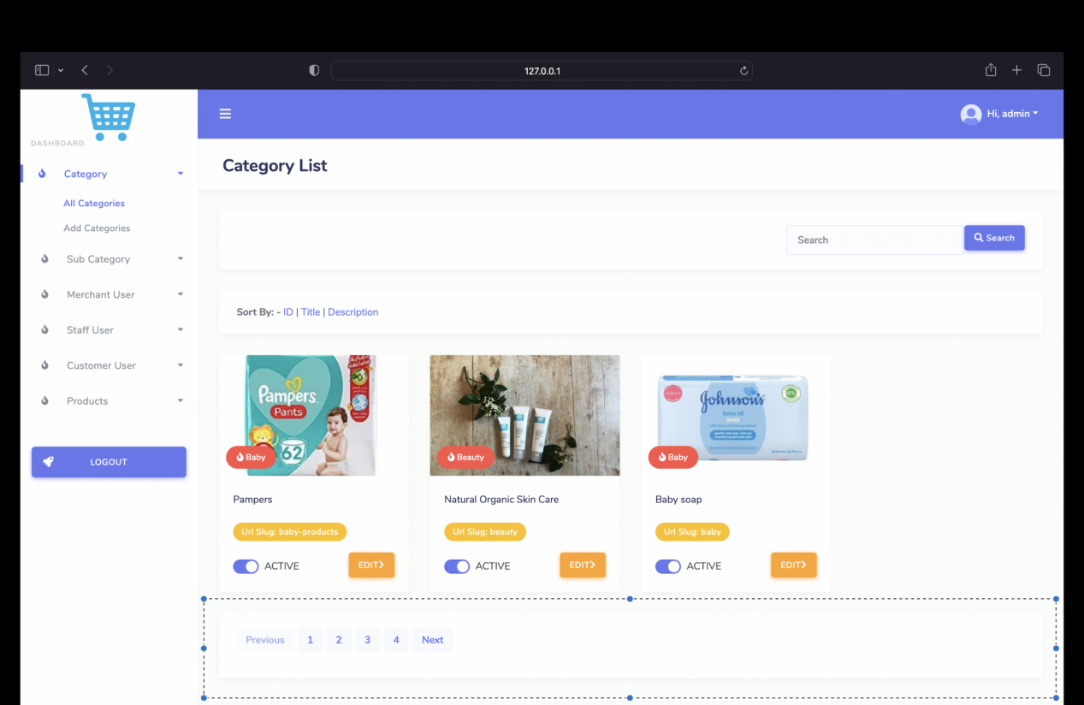

Product Management

Add Product Page With Dynamic Content and Media

The Add Product Page now supports dynamic content and media inclusion, allowing

for richer and more engaging product listings.

Add Product Page With Dynamic Content and Media

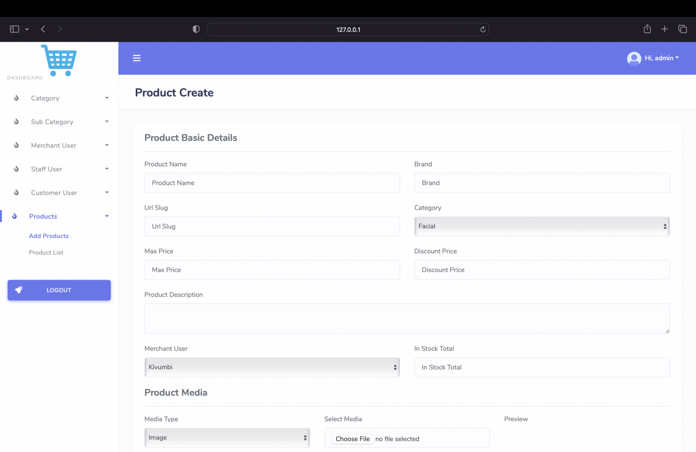

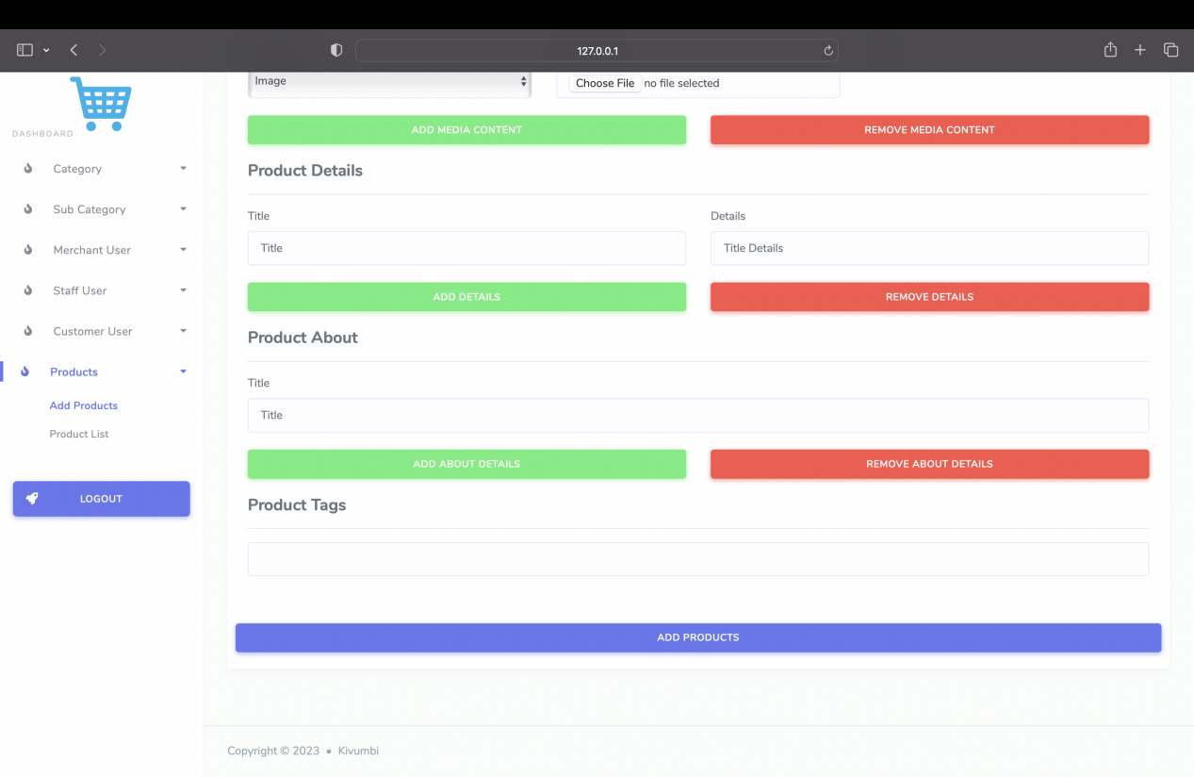

Product List Page

The Product List Page displays an organized inventory of available products,

providing customers with a comprehensive view.

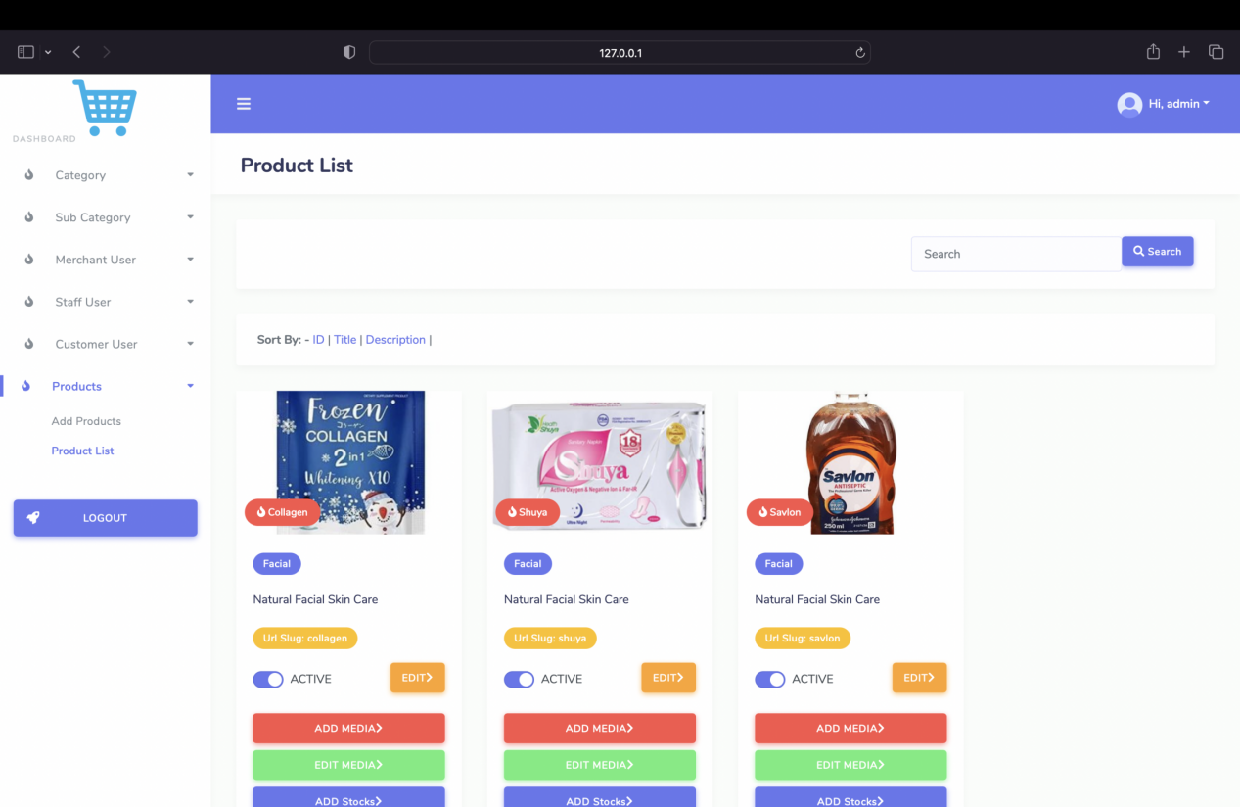

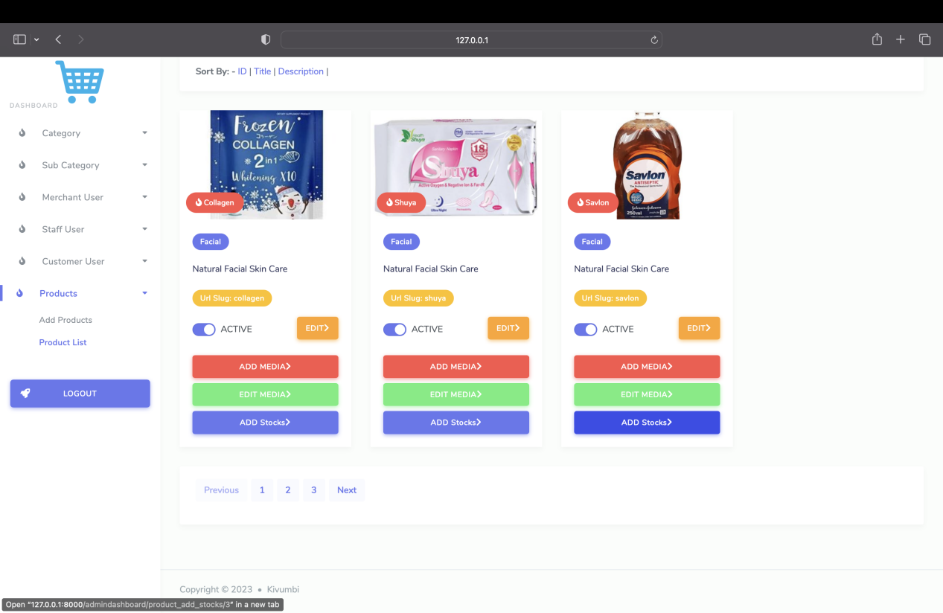

Product List Page

Product Edit

PageAdmins can now edit product details using the Product Edit Page, ensuring accuracy

and relevance of product information.

Product Edit Page

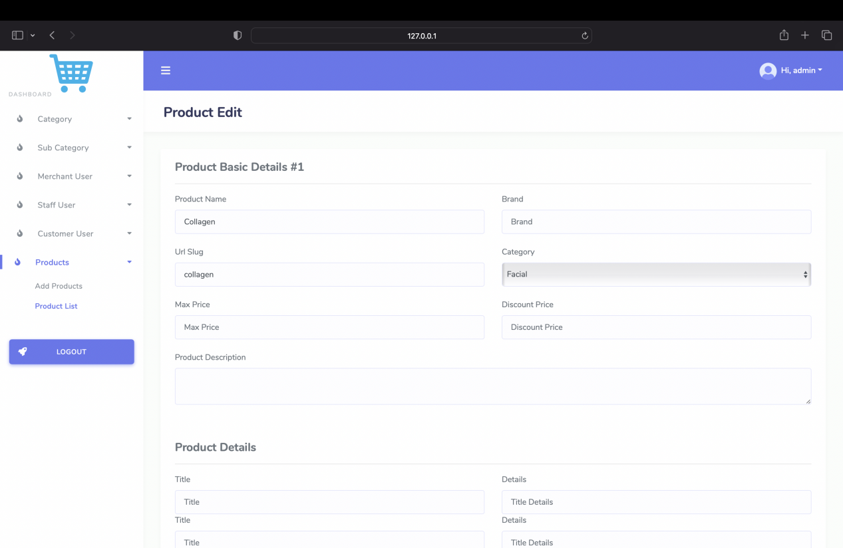

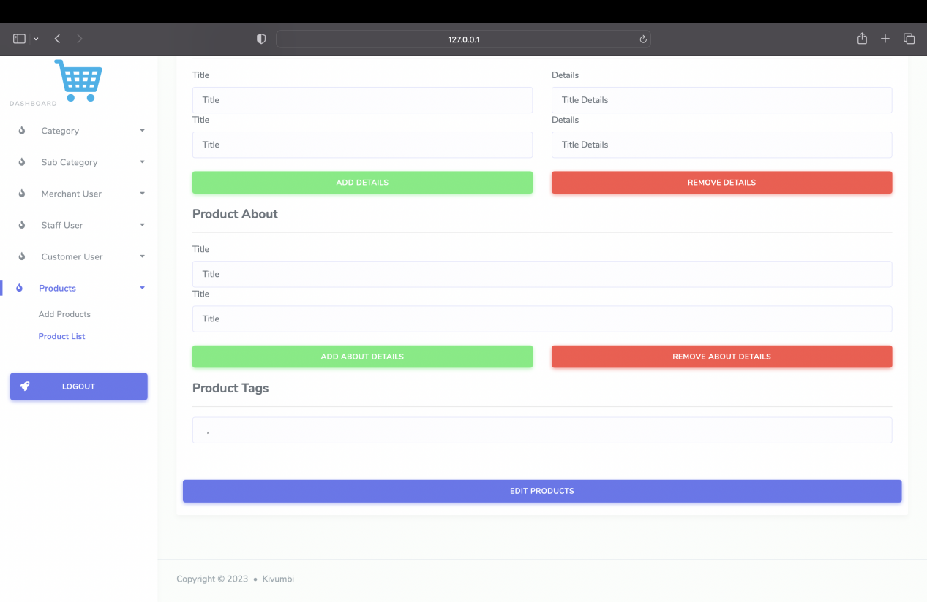

Product Media Management

Add Media Page

The Product Add Media Page allows administrators to upload and associate media

files with specific products, enhancing visual representation.

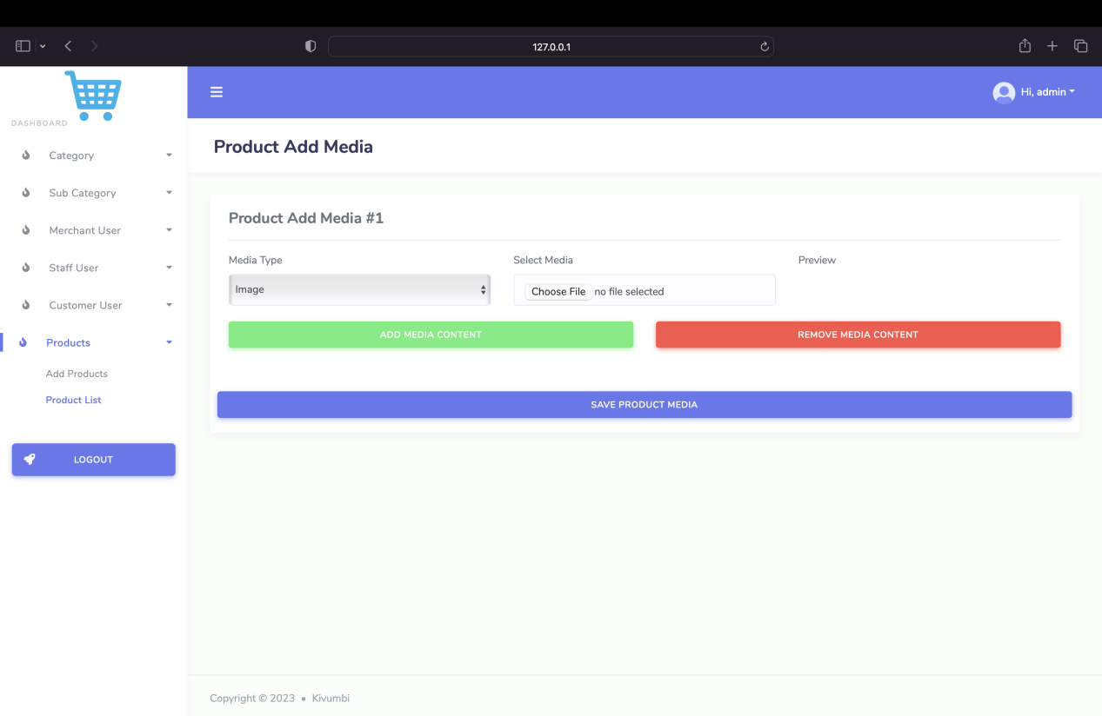

Product Add Media Page

Edit Media Page

The Product Edit Media Page permits administrators to modify and manage media

files associated with products.

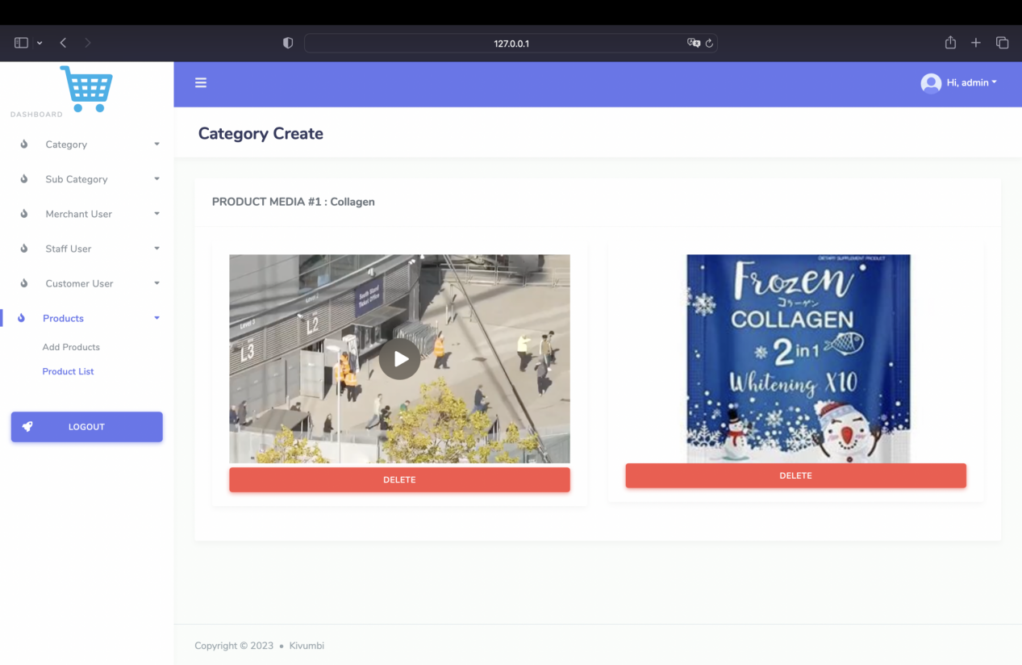

Product Edit Media Page

Product Stock Management

Add Stock Page

Administrators have the ability to update product stock levels using the Product Add

Stock Page, ensuring accurate inventory tracking.

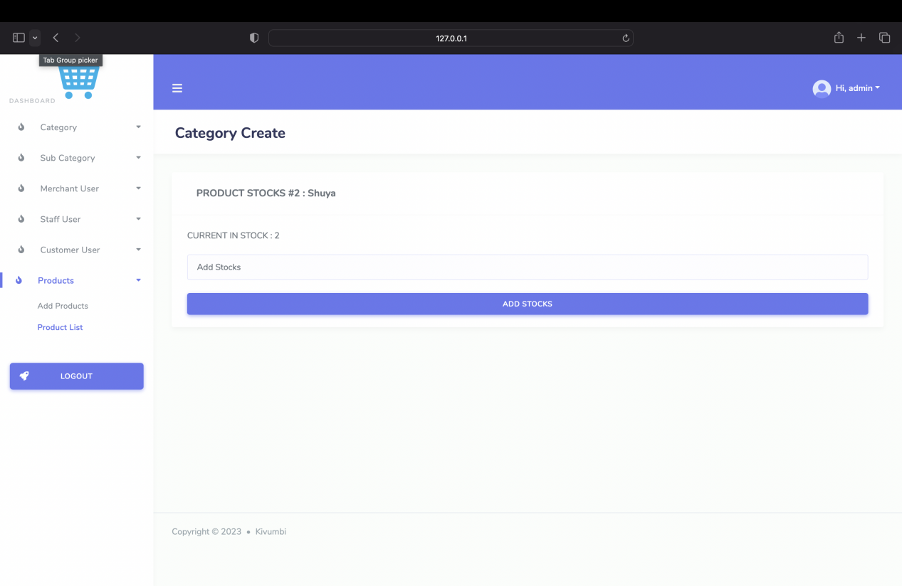

Product Add Stock Page

In conclusion, the django-ecommerce-project has undergone significant development,

introducing various features for efficient category management, merchant

administration, enhanced user experience, and improved product management. These

updates contribute to a more robust and user-friendly ecommerce platform.